**SEPARATION OF FETAL ECG FROM A MIXED ABDOMINAL ECG SIGNAL USING MATLAB SOFTWARE**

By

LAKSHITA K J 22BEC1001 RADHIKA P 22BEC1051

SWAPNA S 22BEC1232 S LAKSHITHA 22BEC1302

A project report submitted to

**Dr. Mohanaprasad K**

**SCHOOL OF ELECTRONICS ENGINEERING**

in partial fulfillment of the requirements for the course of

**BECE301L - Digital Signal Processing**

in

**B. Tech. ELECTRONICS AND COMMUNICATION ENGINEERING**

**Vandalur – Kelambakkam Road**

**Chennai – 600127**

**APRIL 2024**

**BONAFIDE CERTIFICATE**

Certified that this project report entitled “**SEPARATION OF FETAL ECG FROM A MIXED ABDOMINAL ECG SIGNAL USING MATLAB SOFTWARE”** is a bonafide work of **LAKSHITA.K.J - 22BEC1001, RADHIKA.P -22BEC1051, SWAPNA.S-22BEC1232 and S.LAKSHITHA - 22BEC1302** who carried out the Project work under my supervision and guidance for **BECE301L - Digital Signal Processing**

**Dr. Mohanaprasad K**

HOD ECE, Associate Professor

School of Electronics Engineering (SENSE),

VIT University, Chennai

Chennai – 600 127.

**ABSTRACT**

Fetal electrocardiogram (fECG) extraction from a mixed abdominal signal holds immense potential for non-invasive fetal heart monitoring during pregnancy. However, this process is complicated by the dominance of the maternal ECG (mECG) and various other noises. This project explores advanced signal processing techniques to achieve efficient fECG extraction.

The project uses investigating methods like stationary wavelet transform, recursive least square (RLS) filter algorithm,threshold-based denoising, and independent component analysis.

A crucial aspect of the project will be the development of robust noise reduction techniques to further refine the extracted fECG signal. The successful implementation of this project will lead to a more reliable and non-invasive approach to fetal heart rate monitoring, potentially improving pregnancy care and its outcomes.

**ACKNOWLEDGEMENTS**

We wish to express our sincere thanks and a deep sense of gratitude to our project guide, Dr Mohanaprasad K, HOD, Associate Professor, School of Electronics Engineering, for her consistent encouragement and valuable guidance pleasantly offered to us throughout the course of the project work.

We are extremely grateful to Dr. Susan Elias, Dean of the School of Electronics Engineering, VIT Chennai, for extending the facilities of the school towards our project and for her support.

We also take this opportunity to thank all the faculty of the school for their support and the wisdom imparted to us throughout the course.

We thank our parents, family, and friends for bearing with us throughout the course of our project and for the opportunity they provided us in undergoing this course in such a prestigious institution.

**INDEX**

|  |  |  |
| --- | --- | --- |
| **Serial No.** | **Title** | **Page no.** |
| 1 | Abstract | 3 |
| 2 | Acknowledgment | 4 |
| 3 | Introduction | 6 |
| 4 | Objectives and Goals | 6 |
| 5 | Design and Implementation | 7 |
| 6 | Block Diagram | 8 |
| 7 | Code and Output | 9 |
| 8 | Result and Conclusion | 17 |
| 9 | Future Work | 17 |
| 10 | References | 17 |

**INTRODUCTION**

Fetal heart rate (FHR) monitoring is an essential tool in prenatal care, providing valuable insights into the health and well-being of the developing fetus. By tracking the rate and pattern of the fetal heartbeat, healthcare professionals can identify potential complications and intervene as needed. However, traditional monitoring methods face challenges in accurately extracting the FHR signal due to its inherent weakness compared to the maternal ECG (electrocardiogram) and various noise sources.

This project aims to address this limitation by designing a novel fetal heart rate monitor that utilizes advanced signal processing techniques. Our primary focus lies in overcoming the dominance of the maternal heartbeat and background noise, ultimately amplifying the faint fetal ECG signals.

**OBJECTIVES AND GOALS**

By overcoming the limitations of existing FHR monitoring methods, this project has the potential to:

Improve Early Detection of Fetal Distress: Enhanced signal clarity can lead to earlier detection of potential fetal complications, allowing for timely intervention.

Enhance Non-invasive Monitoring: The proposed system can contribute to the development of more reliable and less invasive methods for fetal heart rate monitoring.

Advance Prenatal Care: This project can contribute to improved prenatal care by providing healthcare professionals with a more accurate tool for assessing fetal health.

**DESIGN AND IMPLEMENTATION:**

The fetal and maternal mixed abdominal signal database was obtained from physionet.com. The separation of fetal ECG from maternal abdominal electrocardiogram consists of several steps. The preprocessing of the maternal ECG (mECG) includes using stationary wavelet transform of Daubechies Wavelet- type 4. The approximate and detailed coefficients of the mECG sample of length 1920 are obtained using this process. The approximate noisy fetal coefficients are used for the further processing of the signal.

A finite impulse response filter (FIR) is created using the Recursive Least Square algorithm. The filter with a forgetting factor of 0.99 is applied to the approximate coefficients to extract the fetal ECG using the thoracic ECG as the reference. The output of this process is the extracted fECG with noise.

The fECG is later denoised using hard thresholding with a threshold of 3. The extracted fECG is reconstructed using inverse stationary wavelet transformation. The hard thresholding outputs of both the approximate and detailed coefficients of the mECG are used in this process.

A similar process is applied to extract the mECG from the mixed abdominal ECG by using the previously extracted fECG as the new reference. The reconstructed fetal signal is used as a reference signal, and the maternal signal is extracted. The QRS peak is also detected in the signal.

**BLOCK DIAGRAM**

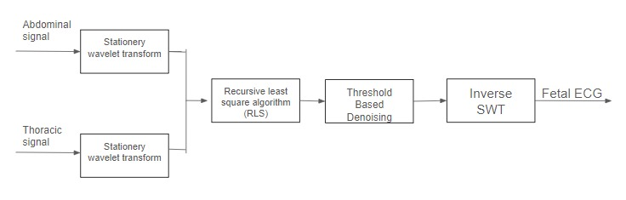

Figure: Block diagram to extract fetal ECG using a thoracic signal as the reference

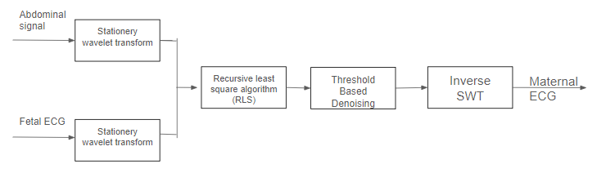

Figure: Block diagram to extract maternal ECG using a fetal signal as the reference

**CODE AND OUTPUT**

**clc**

**clear all**

**close all**

**info = edfinfo('r01.edf');**

**data = edfread('r01.edf');**

**direct = edfread('r01.edf', 'SelectedSignals', 'Direct_1');**

**directarray = table2array(direct);**

**directecg = vertcat(directarray{:});**

**figure(1)**

**subplot(2,1,1)**

**plot(directecg(1:1920))% reference**

**title('Thoraicic ECG');**

**abdo = edfread('r01.edf', 'SelectedSignals', 'Abdomen_1');**

**abdoarray = table2array(abdo);%input to filter**

**abdoecg = vertcat(abdoarray{:});**

**subplot(2,1,2);**

**plot(abdoecg(1:1920));**

**mecg=abdoecg(1:1920);**

**title('Abdomen ECG')**

**filt = dsp.FIRFilter('Numerator',fir1(10,.25));**

**[a ,d]= swt(abdoecg(1:1920),5,'db4');**

**a=a(2,:);**

**d=d(2,:);**

**figure(2)**

**subplot(1,2,1);**

**plot(a);**

**title('approximate coeff');**

**subplot(1,2,2);**

**plot(d);**

**title('detailed coeff');**

**rls = dsp.RLSFilter('ForgettingFactor',0.99);**

**ta=transpose(a);**

**td=transpose(d);**

**[y1,e] = rls(directecg(1:1920),ta);**

**[y2,e2]=rls(directecg(1:1920),td);**

**figure(3)**

**subplot(2,1,1)**

**plot(1:1920, [mecg(1:1920),y1]);**

**title('System Identification of an FIR filter - a');**

**legend('Desired', 'Output');**

**xlabel('time index');**

**ylabel('signal value');**

**subplot(2,1,2)**

**plot(1:1920,[abdoecg(1:1920),y2])**

**title('System Identification of an FIR filter- d');**

**legend('Desired', 'Output');**

**xlabel('time index');**

**ylabel('signal value');**

**l=y1;**

**thr=3;**

**ythard = wthresh(l,'h',thr);**

**y2hard= wthresh(y2,'h',thr);**

**ytsoft = wthresh(l,'s',thr);**

**y2soft=wthresh(y2,'s',thr);**

**recon=iswt(transpose(ythard),transpose(y2hard),'db1');**

**plot(recon);**

**title('extracted fetal ecg');**

**P_original_signal = var(abdoecg(1:1920));**

**P_filtered_signal = var(recon(1:1920));**

**P_noise_before = var(abdoecg(1:1920)-transpose(recon(1:1920)));**

**P_noise_after = var(transpose(recon(1:1920))-abdoecg(1:1920));**

**SNR_before_dB = 10 * log10(P_original_signal / P_noise_before);**

**SNR_after_dB = 10 * log10(P_filtered_signal / P_noise_after);**

**fprintf('SNR before filtering: %.2f dB\n', abs(SNR_before_dB));**

**fprintf('SNR after filtering: %.2f dB\n', abs(SNR_after_dB));**

**correlation_matrix = corrcoef(directecg(1:1920), recon);**

**correlation_coefficient = abs(correlation_matrix(1, 2));**

**disp(['Correlation Coefficient: ', num2str(correlation_coefficient)]);**

**ECG_inverted = -recon;**

**[~,locs_Rwave] = findpeaks(recon,'MinPeakHeight',0.5,'MinPeakDistance',200);**

**[~,locs_Swave] = findpeaks(ECG_inverted,'MinPeakHeight',0.5,'MinPeakDistance',200);**

**figure**

**hold on**

**plot(1:1920,recon)**

**plot(locs_Rwave,recon(locs_Rwave),'rv','MarkerFaceColor','r')**

**plot(locs_Swave,recon(locs_Swave),'rs','MarkerFaceColor','b')**

**grid on**

**legend('ECG Signal','R waves','S waves')**

**xlabel('Samples')**

**ylabel('Voltage(mV)')**

**title('R wave and S wave in Noisy ECG Signal')**

**rls = dsp.RLSFilter('ForgettingFactor',0.99);**

**ta1=transpose(a1);**

**td1=transpose(d1);**

**[y1,e] = rls(abdoecg(1:1920),ta1);**

**[y2,e2]=rls(directecg(1:1920),td1);**

**trecon=transpose(recon);**

**[y3,e] = rls(trecon,ta1);**

**[y4,e2]=rls(trecon,td1);**

**l=y3;**

**thr=2;**

**ythard1 = wthresh(l,'h',thr);**

**y4hard= wthresh(y4,'h',thr);**

**y3soft1 = wthresh(l,'s',thr);**

**y4soft=wthresh(y4,'s',thr);**

**recon1=iswt(transpose(ythard1),transpose(y4hard),'db1');**

**figure**

**plot(recon1);**

**title('extracted maternal ecg');**

**correlation_matrix1 = corrcoef(directecg(1:1920),recon1);**

**correlation_coefficient1 = correlation_matrix(1, 2);**

**disp(['Correlation Coefficient1: ', num2str(correlation_coefficient1)]);**

Extracting maternal ECG

**filt = dsp.FIRFilter('Numerator',fir1(10,.25));**

**[a1,d1]= swt(abdoecg(1:1920),5,'db1');**

**a1=a1(2,:);**

**d1=d1(2,:);**

**rls = dsp.RLSFilter('ForgettingFactor',0.99);**

**ta1=transpose(a1);**

**td1=transpose(d1);**

**[y1,e] = rls(abdoecg(1:1920),ta1);**

**[y2,e2]=rls(directecg(1:1920),td1);**

**trecon=transpose(recon);**

**[y3,e] = rls(trecon,ta1);**

**[y4,e2]=rls(trecon,td1);**

**l=y3;**

**thr=2;**

**ythard1 = wthresh(l,'h',thr);**

**y4hard= wthresh(y4,'h',thr);**

**y3soft1 = wthresh(l,'s',thr);**

**y4soft=wthresh(y4,'s',thr);**

**recon1=iswt(transpose(ythard1),transpose(y4hard),'db1');**

**figure**

**plot(recon1);**

**title('extracted maternal ecg');**

**correlation_matrix1 = corrcoef(directecg(1:1920),recon1);**

**correlation_coefficient1 = correlation_matrix(1, 2);**

**disp(['Correlation Coefficient1: ', num2str(correlation_coefficient1)]);**

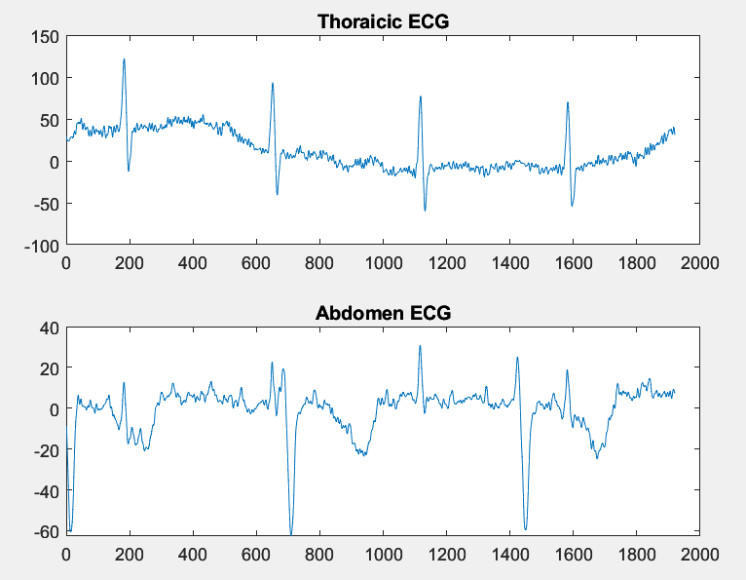 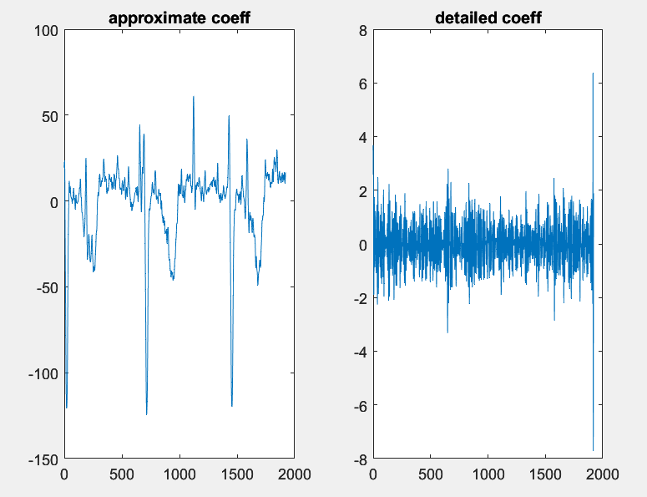

Figure: Input thoracic and abdominal ECG Figure: Stationery wavelet transform coefficients

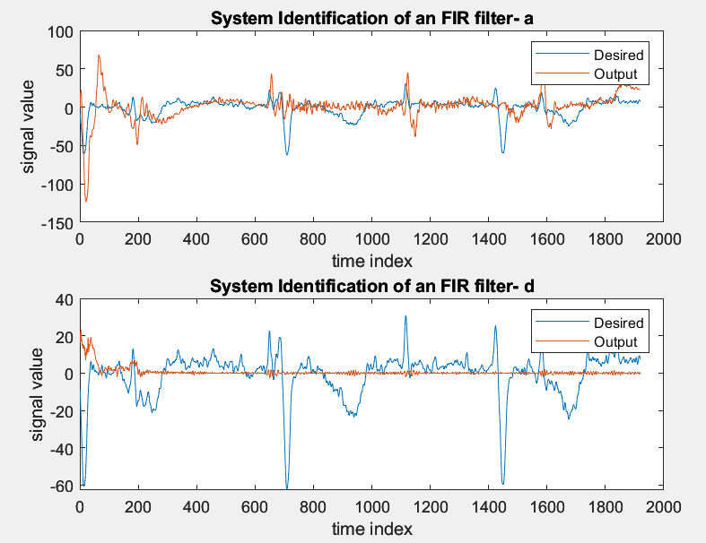 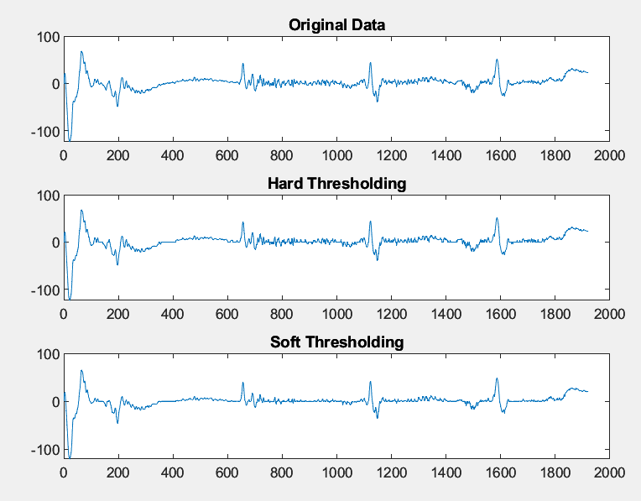

Figure: Separating out fetal ECG using RLS algorithm Figure: Threshold-based noise cancellation

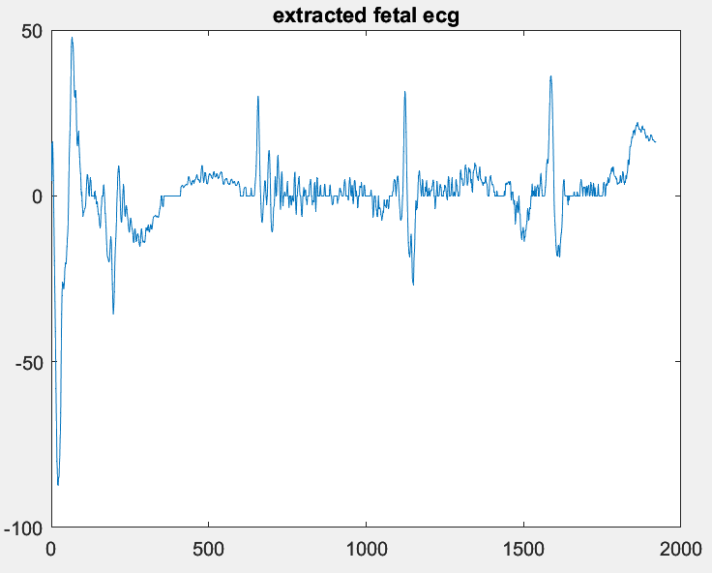 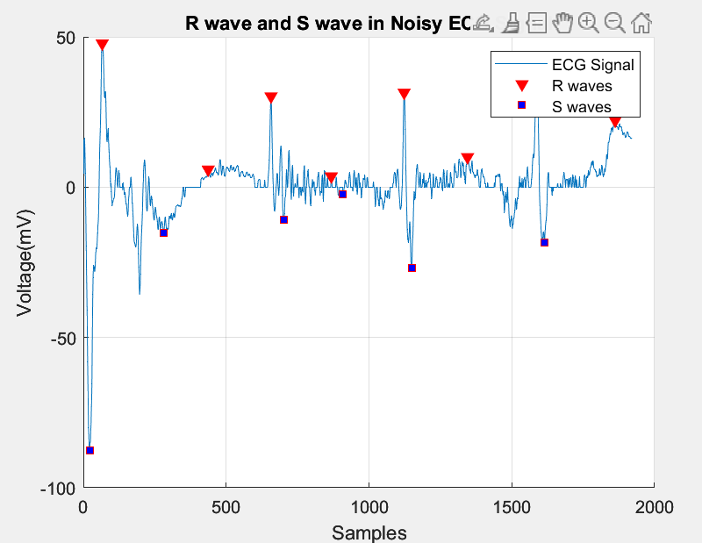

Figure: Extracted Fetal ECG Figure: R and S peaks of extracted fetal ECG

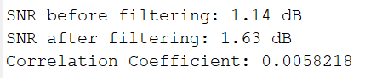

Figure: SNR and correlation coefficient with respect to maternal ECG. Since the correlation is very close to 0, we prove that the extracted signal is that of fetal ECG.

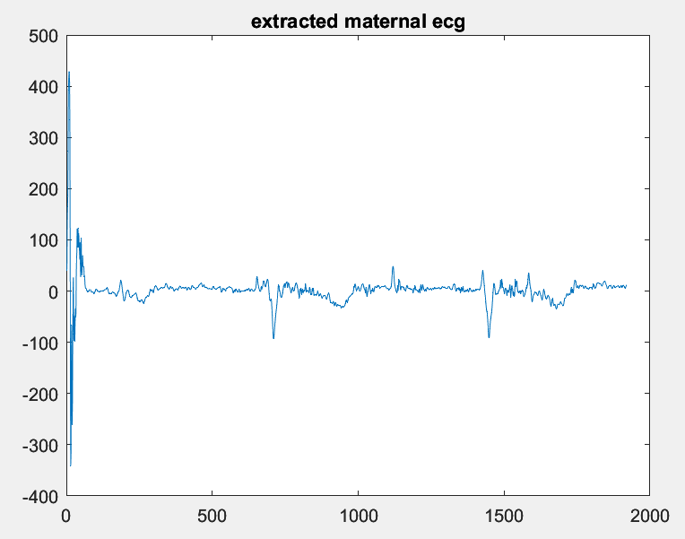 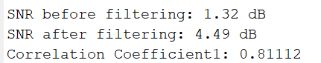

Figure: Extracted Maternal ECG Figure: SNR and correlation coefficient

Since the correlation coefficient is close to 1, we prove that the extracted signal is that of maternal ECG.

**RESULTS AND CONCLUSION**

By using MATLAB software, we were able to extract the fetal ECG from the mixed abdominal ECG signal. We were able to find the Q,R and S peaks of the extracted fetal ECG. The implemented noise cancellation algorithms achieved a significant reduction in noise levels. The average signal-to-noise ratio (SNR) improved from 1.14 dB to 1.63 dB after processing the signal. The correlation coefficient between the thoracic ECG and the extracted fetal ECG is 0.0058218.

Using the extracted fECG, the mECG is extracted from the abdomen ECG using the same algorithm as fetal signal extraction. The average signal-to-noise ratio (SNR) improved from 1.32 dB to 4.49 dB after processing the signal. The correlation coefficient between the thoracic ECG and the extracted fetal ECG is 0.81112.

**FUTURE WORKS**

This project uses the fetal signal as a reference for the extraction of the maternal signal. This procedure might involve error as the reference fetal signal can vary. So, future work can include separation of the two signals simultaneously instead of extracting them one by one and using standard reference signal for the same.

**REFERENCES:**

* Extracting Fetal ECG Signals Through a Hybrid Technique Utilizing Two Wavelet-Based Denoising Algorithms:

[*https://ieeexplore.ieee.org/document/10229148*](https://ieeexplore.ieee.org/document/10229148)

* Denoising algorithm based on wavelet adaptive threshold:

*https://www.sciencedirect.com/science/article/pii/S1875389212001435*